How to Create Catalog Entries in BiblioteQ

Go to the upper left hand corner, click ‘File’, go to the second option down ‘Recent SQLite Files’ and click the one that appears.

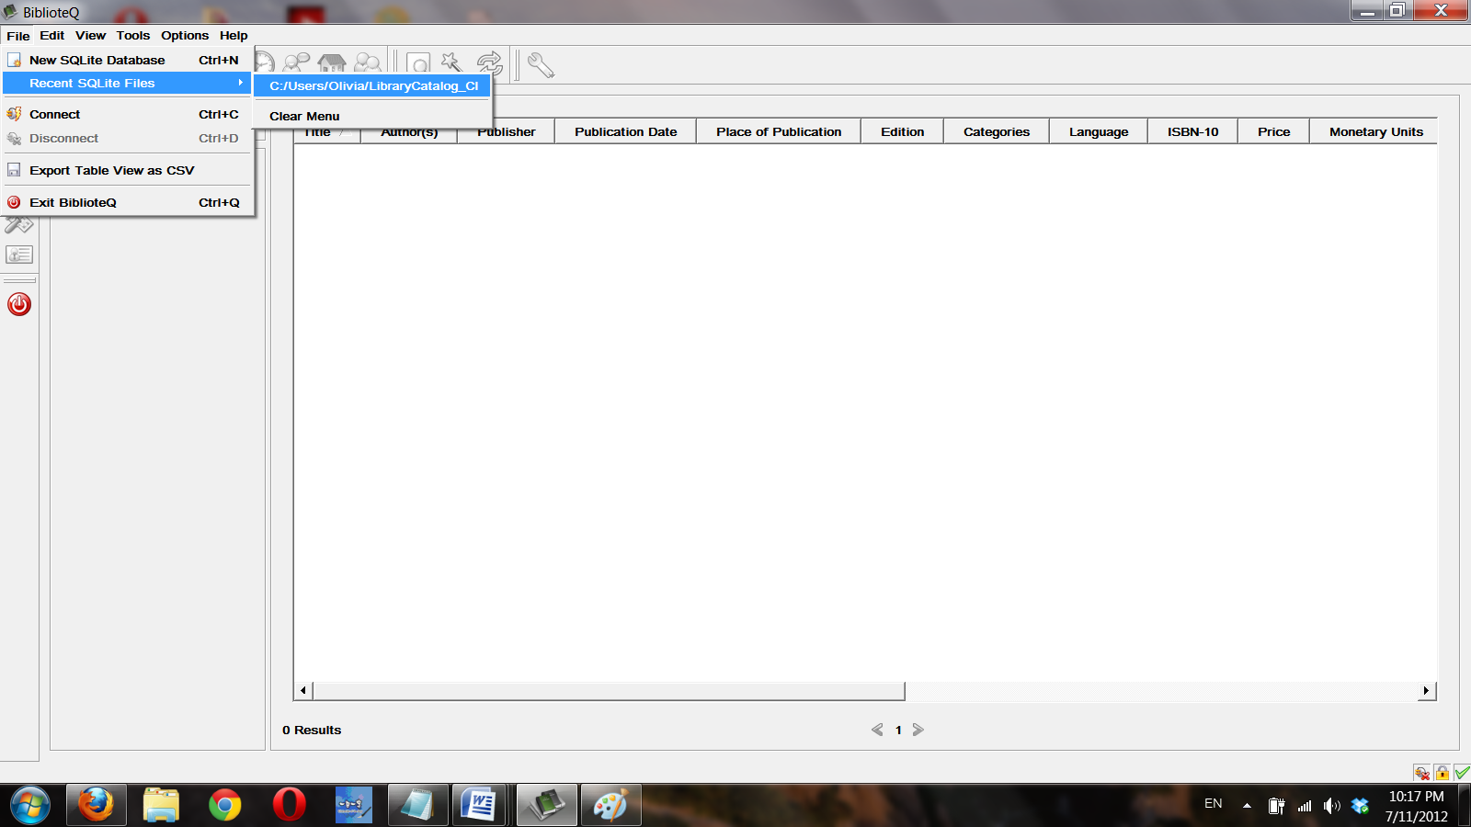

Now that the database is open, you can edit the existing catalog entries and add new ones. On the left of the toolbar, you’ll see a green + Click on it and options will appear for you to insert a new entry based on type. If you’d like to insert a book, click on the first option ‘Insert Book’

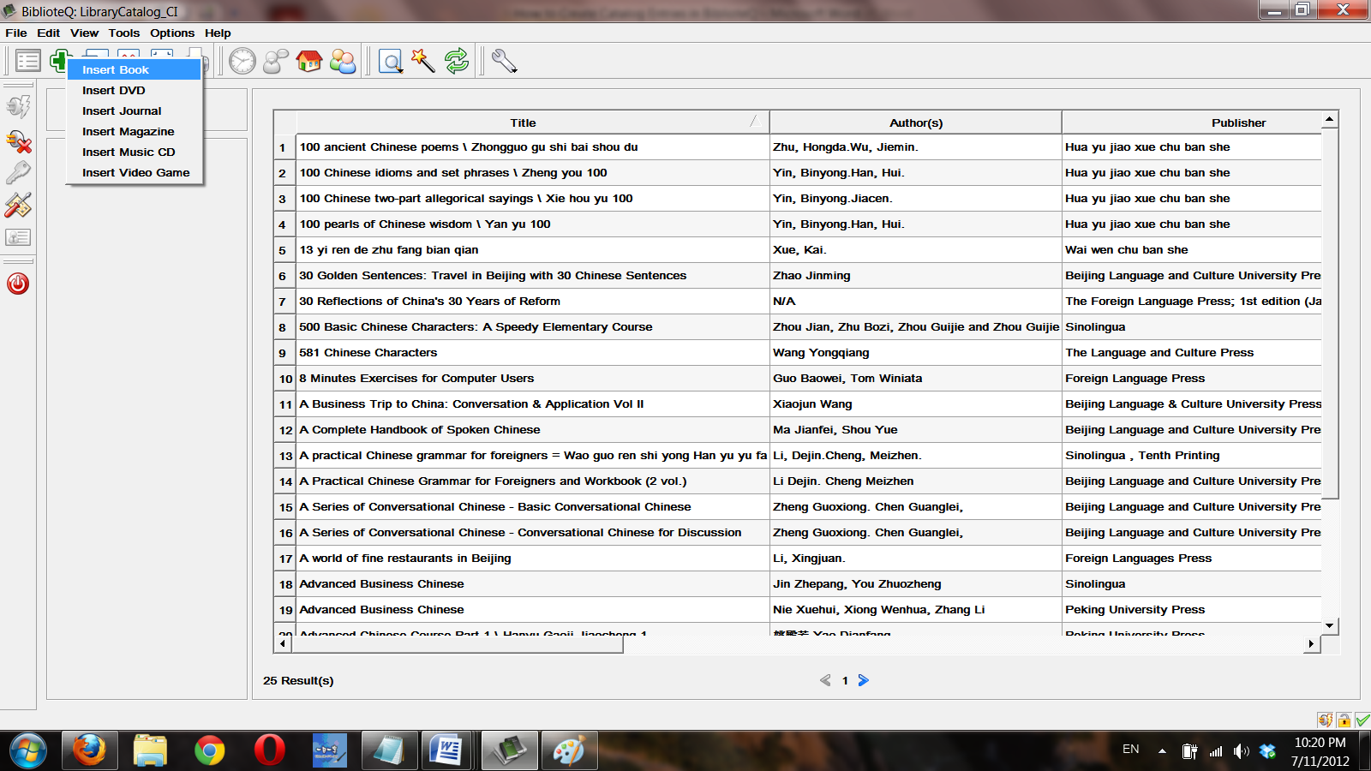

Now a blank new entry screen appears. The first field you’ll want to enter data in is the ‘ISBN – 13’ field.

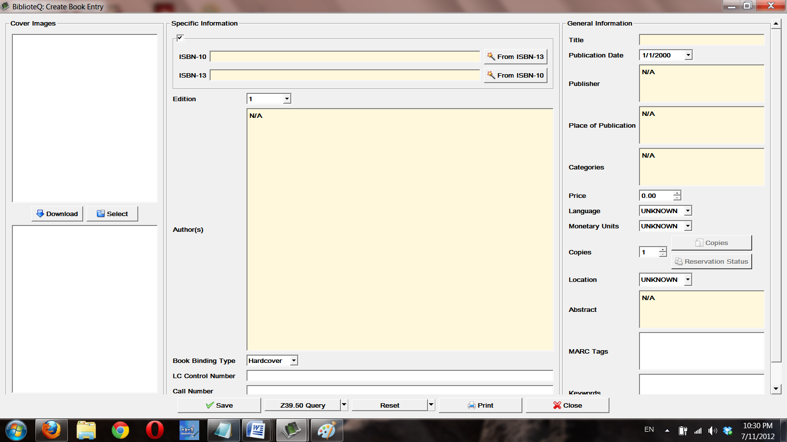

Locate the 13-digit ISBN on the book cover. You can usually get the ISBN from the lower corner on the back cover of the book (a few volumes do not have an ISBN) (Some volumes have an ISBN located on the inside back cover). You can either manually type it in or scan it with the barcode scanner. (Only the topmost row or the bottom left row are the numbers you need.)



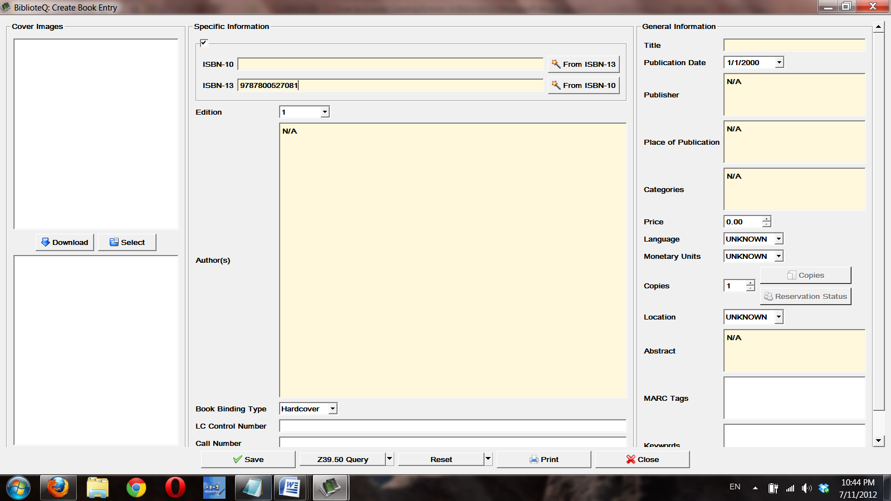

Now that there’s an ISBN-13 entered, sometimes the catalog information can be automatically entered through a Z39.50 query. You must be connected to the internet to do this. The query is done by clicking ‘Z39.50 Query’ at the bottom. The default setting is to query the Library of Congress database. If an error message appears, the next option is to change the database to Columbia University. To do so click on the downward arrow next to the ‘Z39.50 Query’ button and select ‘Columbia University’. Once selected, click on ‘Z39.50 Query’ again. If an error message pops up once more, you’ll simply have to manually enter the book’s information: Title, Publisher, Publication Date, Place of Publication, Authors, Book Binding Type, Categories, etc. Abstracts can often be found on the back cover if you’d like to type it in, or are sometimes available on Amazon and elsewhere online if you prefer to copy and paste what’s available. Follow the ‘Classification’ guide for BiblioteQ to fill out the ‘Call Number’ and ‘MARC Tags’ field. If there are multiple copies, enter the number of copies available (including those in reference with the reference tag included in the MARC Tags field). 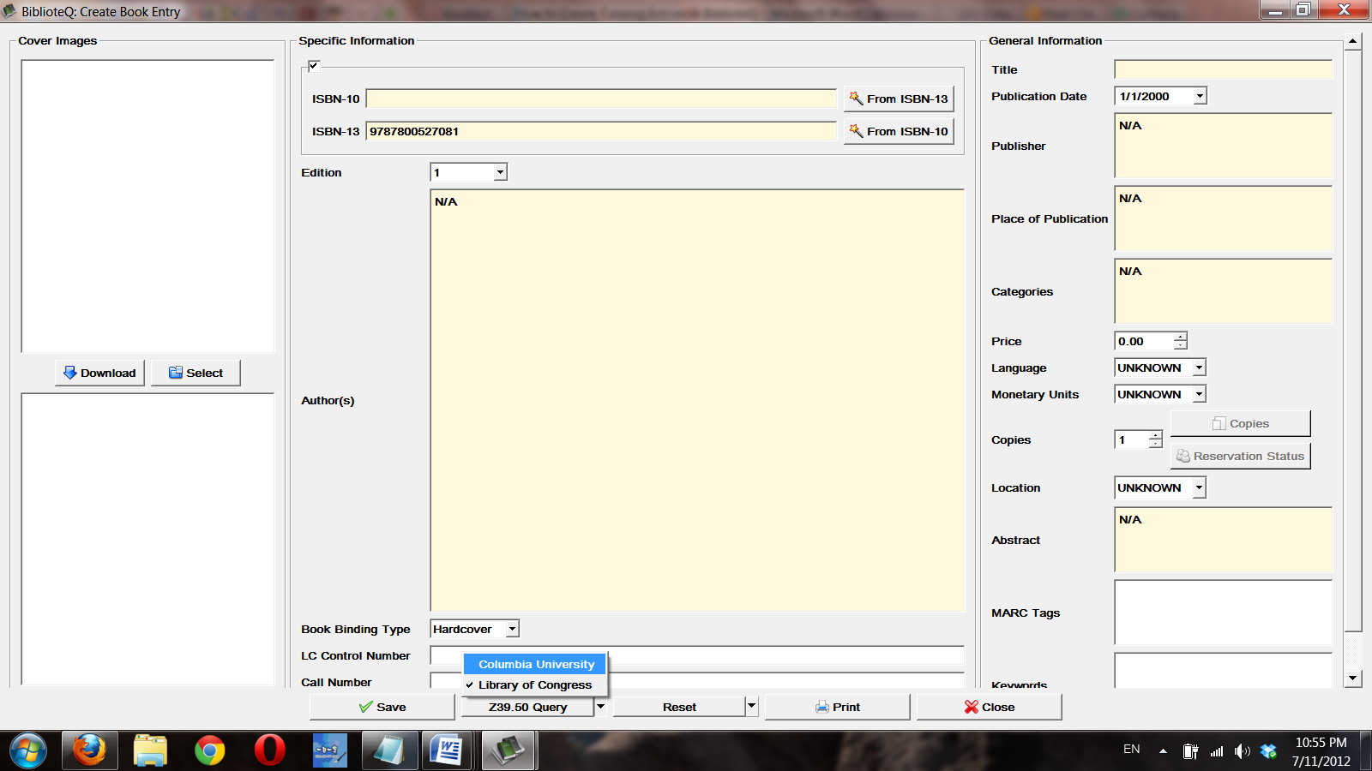

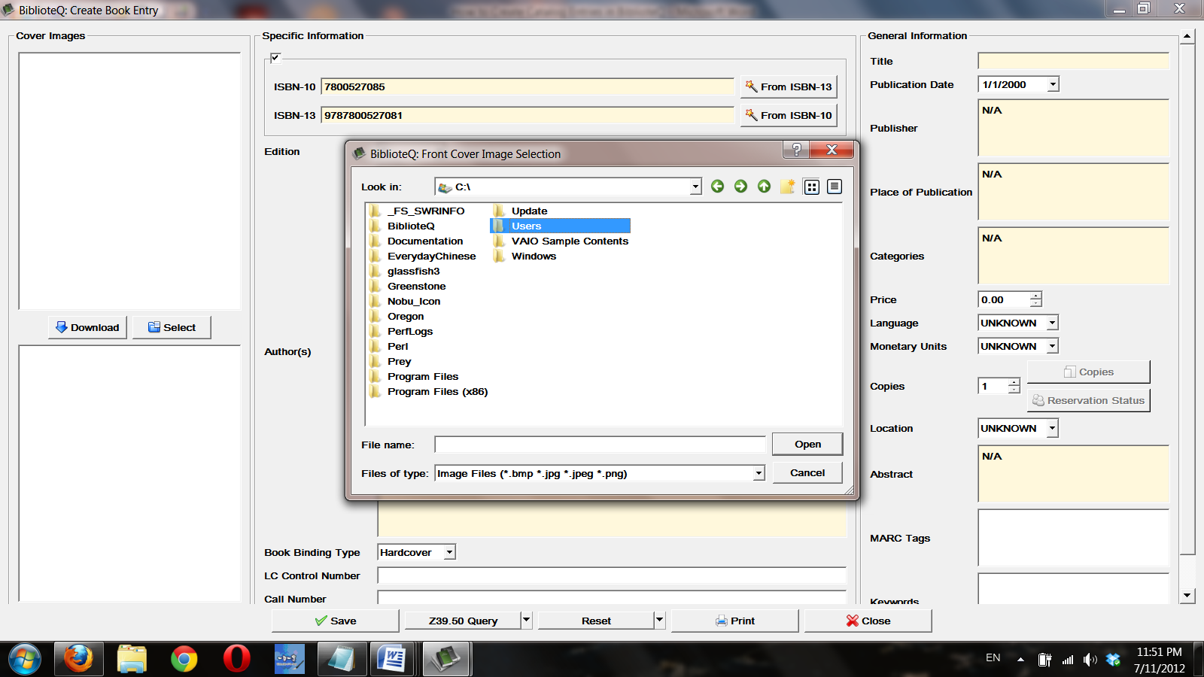

For the entry’s image, (assuming you don’t want to or can’t scan the original book, you can skip this step if physically scanning is a faster/better option for you, you just need to scan it into the computer and then save and ‘Select’ the local file), an ISBN-10 is necessary. This can be easily converted from the ISBN-13 by clicking ‘From ISBN-13’ on the right of the ISBN-10 field. After you have the ISBN-10, click ‘Download’. If an error message pops up, then the next step is to do a web search with the ISBN-13. You can use Baidu, Google Image, or whichever search engine is most effective for you. My first resort is Amazon, which is available in both Chinese and English, if no results appear, then onto Google Image, etc. Google will usually bring up merchants where further information appears to confirm that the image is the cover of the book you want. The image helps to distinguish volumes when multiple editions are available and have the same title, and generally makes finding the book on the shelf easier.

Once all the data is entered, click ‘Save’ at the bottom. Entries may be edited later if new copies or other information becomes available.